EXPERIMENT 20
LPC-Based Speech Analysis and Vocoder Implementation Using MATLAB
B.E. Electronics and Communication Engineering (ECE)
Name: Lokesh A Register Number: 192512293
Date: 13 October 2026
1. AIM
To analyze a speech-like signal using Linear Predictive Coding (LPC), estimate its spectral envelope and formant frequencies, and implement frame-by-frame LPC vocoder synthesis using MATLAB.
2. SOFTWARE REQUIRED
- MATLAB
- Signal Processing Toolbox functions such as lpc, freqz, pwelch, and resample (as applicable)
3. THEORY
Linear Predictive Coding (LPC) is a speech-processing technique that models a speech sample as a linear combination of previous samples. The LPC analysis estimates predictor coefficients that represent the spectral characteristics of a short speech frame. The resulting all-pole filter approximates the vocal-tract response.
For a prediction order p, the current sample is approximated from previous samples as x[n] ≈ −a₁x[n−1] − a₂x[n−2] − … − aₚx[n−p]. The LPC synthesis filter is H(z) = G / A(z), where A(z) is the polynomial formed from the LPC coefficients and G is the excitation gain.
Speech is processed in short, overlapping frames because its characteristics change over time. In a simple LPC vocoder, an excitation signal is passed through the all-pole synthesis filter. Random-noise excitation is commonly used to approximate unvoiced excitation; voiced speech generally requires a periodic or pitch-based excitation for more natural synthesis.
4. PARAMETERS USED
Parameter | Value
Sampling frequency | 8000 Hz
Input signal length | 4000 samples
Frame length | 240 samples (30 ms)
Frame shift | 120 samples (15 ms)
LPC prediction order | 12
Excitation | Random noise with fixed random seed
5. ALGORITHM / PROCEDURE
- Initialize MATLAB and define the sampling frequency, frame length, frame shift, and LPC prediction order.
- Load the speech_sample.wav file if available; convert stereo audio to mono and resample it to 8 kHz when required. If the file is unavailable, use the synthetic test signal.
- Normalize the input signal and divide it into overlapping frames using a Hamming window.
- Compute the LPC coefficients and prediction error energy for each frame.
- Generate random-noise excitation and pass it through the all-pole LPC synthesis filter.
- Overlap-add the synthesized frames and normalize by the accumulated window gain.
- Analyze a selected frame using LPC and Welch spectral estimation, then estimate plausible formant frequencies from the LPC poles.
- Display the numerical results and plot the input waveform, spectrum with LPC envelope, and vocoder output.
6. MATLAB PROGRAM
clc; clear; close all;
%% EXPERIMENT 20: LPC SPEECH ANALYSIS AND VOCODER
Fs = 8000;
N_frame = 240;
hop = 120;
p = 12;
if isfile('speech_sample.wav')
[x_speech, Fs_file] = audioread('speech_sample.wav');
if size(x_speech,2) > 1
x_speech = mean(x_speech,2);
end
if Fs_file ~= Fs
x_speech = resample(x_speech, Fs, Fs_file);
end
x_speech = x_speech(:)';
else
duration = 0.5;
t_temp = 0:1/Fs:duration-1/Fs;
x_speech = sin(2*pi*250*t_temp) + 0.5*sin(2*pi*700*t_temp);
end
x_speech = x_speech / (max(abs(x_speech)) + eps);
t = (0:length(x_speech)-1)/Fs;
win = hamming(N_frame)';
num_frames = floor((length(x_speech)-N_frame)/hop)+1;
x_synth = zeros(1,length(x_speech));
win_gain = zeros(1,length(x_speech));
rng(42);
for m = 1:num_frames
idx = (m-1)*hop + (1:N_frame);
frame = x_speech(idx).*win;
[a,E] = lpc(frame,p);
G = sqrt(max(E,0));
excitation = G*randn(1,N_frame);
synth_frame = filter(1,a,excitation);
x_synth(idx) = x_synth(idx) + synth_frame.*win;
win_gain(idx) = win_gain(idx) + win.^2;
end
valid = win_gain > 1e-6;
x_synth(valid) = x_synth(valid)./win_gain(valid);
frame_start = min(1+floor(length(x_speech)/4), ...
length(x_speech)-N_frame+1);
frame_sample = x_speech(frame_start:frame_start+N_frame-1).*win;
[a_sample,E_sample] = lpc(frame_sample,p);
G_sample = sqrt(max(E_sample,0));
[H_lpc,f_lpc] = freqz(G_sample,a_sample,2048,Fs);
[Pxx,f_fft] = pwelch(frame_sample,win,0,2048,Fs);
r = roots(a_sample);
r = r(imag(r)>0);
formant_freq = angle(r)*Fs/(2*pi);
bandwidth = -Fs/pi*log(max(abs(r),eps));
keep = formant_freq > 90 & formant_freq < Fs/2 & bandwidth < 400;
formant_freq = sort(formant_freq(keep));
fprintf('EXPERIMENT 20: LPC SPEECH ANALYSIS AND VOCODER\\n');
fprintf('Input Signal Length: %d samples\\n',length(x_speech));
fprintf('Sampling Rate: %d Hz\\n',Fs);
fprintf('Frame Length: %d samples (%.1f ms)\\n',N_frame,1000*N_frame/Fs);
fprintf('Frame Shift: %d samples (%.1f ms)\\n',hop,1000*hop/Fs);
fprintf('LPC Prediction Order: %d\\n',p);
fprintf('LPC Coefficients: '); fprintf('%.4f ',a_sample); fprintf('\\n');
fprintf('Gain (G): %.6f\\n',G_sample);
fprintf('Prediction Error Energy (E): %.6f\\n',E_sample);
for k = 1:min(3,length(formant_freq))
fprintf('Formant %d: %.2f Hz\\n',k,formant_freq(k));
end
figure('Name','Experiment 20A: Input Speech','NumberTitle','off');
plot(t,x_speech,'b'); grid on; box on;
title('Input Speech Signal'); xlabel('Time (s)'); ylabel('Amplitude');
figure('Name','Experiment 20B: LPC Spectrum','NumberTitle','off');
plot(f_fft,10*log10(Pxx+eps),'b'); hold on;
plot(f_lpc,20*log10(abs(H_lpc)+eps),'r','LineWidth',1.2);
grid on; box on; xlim([0 Fs/2]);
title('Speech Spectrum and LPC Spectral Envelope');
xlabel('Frequency (Hz)'); ylabel('Magnitude (dB)');
legend('Estimated Speech Spectrum','LPC Envelope');
figure('Name','Experiment 20C: Vocoder Output','NumberTitle','off');
plot(t,x_synth,'m'); grid on; box on;
title('LPC Vocoder Synthesized Signal');
xlabel('Time (s)'); ylabel('Amplitude');
7. OBSERVED OUTPUT
The MATLAB command window and plots show the following results for the run represented in the supplied screenshots:
Output parameter | Observed value
Input signal length | 4000 samples
Sampling rate | 8000 Hz
Frame length | 240 samples (30 ms)
Frame shift | 120 samples (15 ms)
LPC prediction order | 12
Gain G | 0.008292
Prediction error energy E | 0.000069
Estimated formant F1 | 250.66 Hz
Estimated formant F2 | 701.93 Hz
LPC coefficient vector observed in the screenshot:
1.0000, −1.8893, 0.6963, 0.3719, 0.0894, −0.0881, −0.1428, −0.0995, −0.0108, 0.0650, 0.0848, 0.0354, −0.0370
8. MATLAB OUTPUT FIGURES
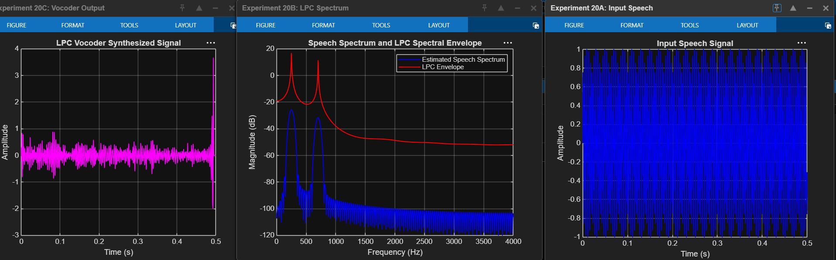
Figure 20A–20C: Input speech, LPC spectral envelope, and vocoder output (MATLAB screenshots).
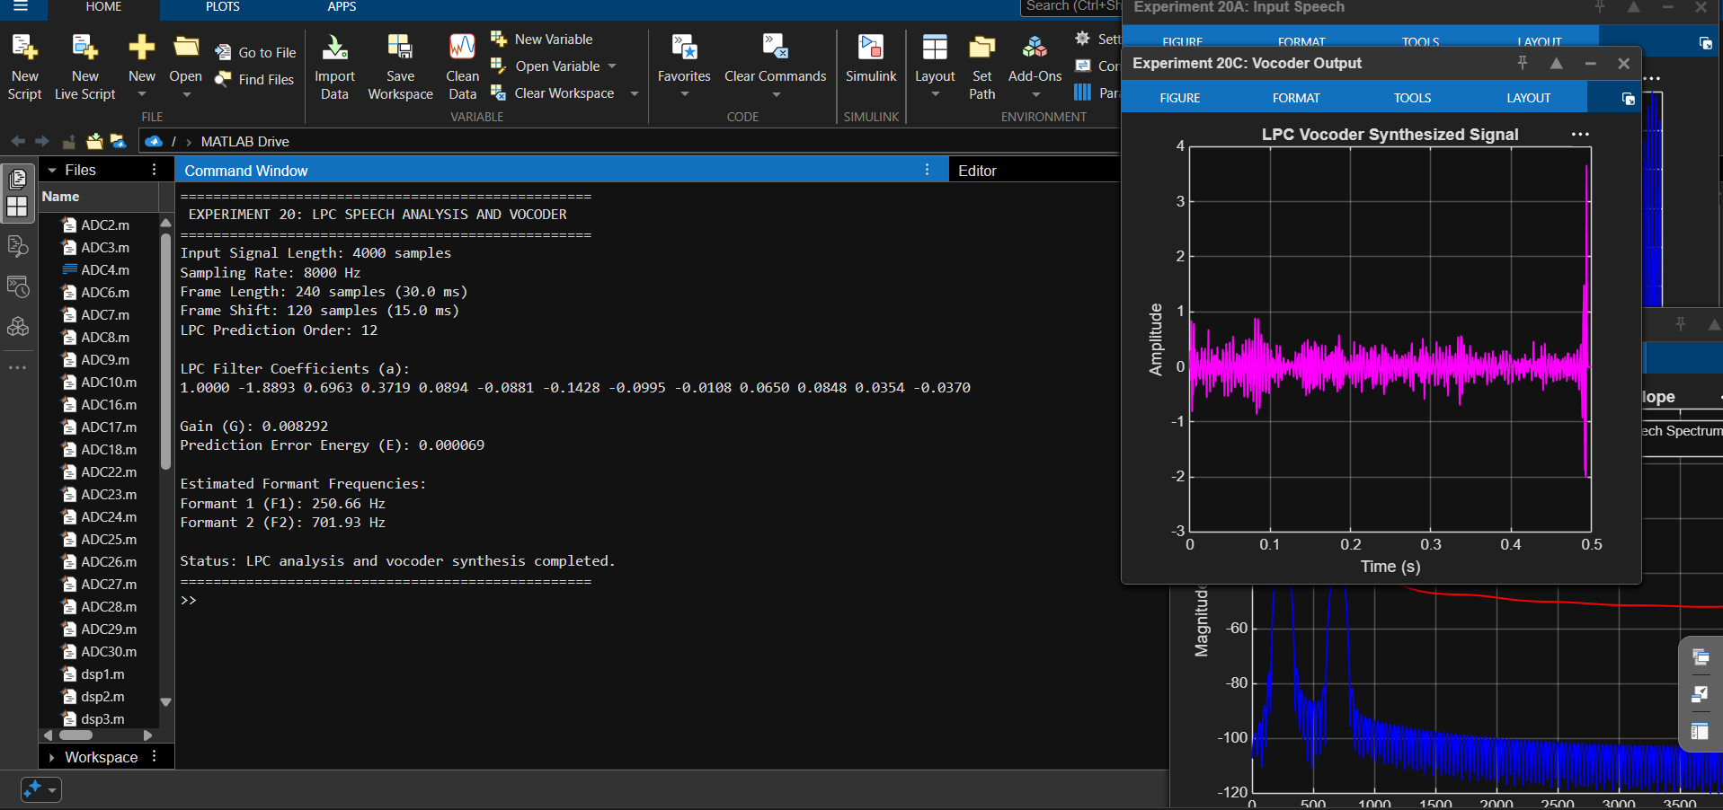
Figure 20: Command-window results and synthesized output (MATLAB screenshot).
9. RESULT
LPC-based speech analysis and vocoder synthesis were implemented in MATLAB. The LPC model was used to obtain predictor coefficients, prediction error energy, and an estimated spectral envelope. Formant frequencies were estimated from the LPC poles, and a frame-based synthesized output was generated.
10. CONCLUSION
The experiment demonstrates the use of Linear Predictive Coding for compact speech modeling and spectral analysis. The LPC coefficients describe the resonant characteristics of the selected signal frame, while the all-pole synthesis filter generates a vocoder output from an excitation signal. The quality of synthesized speech depends on the excitation model, frame overlap, and accuracy of the LPC model.

